

UNIVERSITY OF THE WESTERN CAPE
TUTORIAL 2

WEEK 4 (14 – 18 SEP)

INFORMATION SYSTEMS
244

Student Surname , Name : Batyi, Mbasa
Student Number : 4540469
Group : 01

p

1 | PL/SQL code
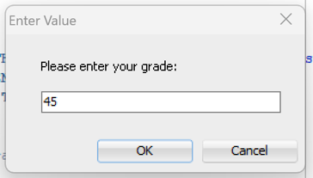
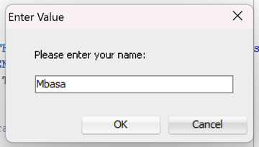
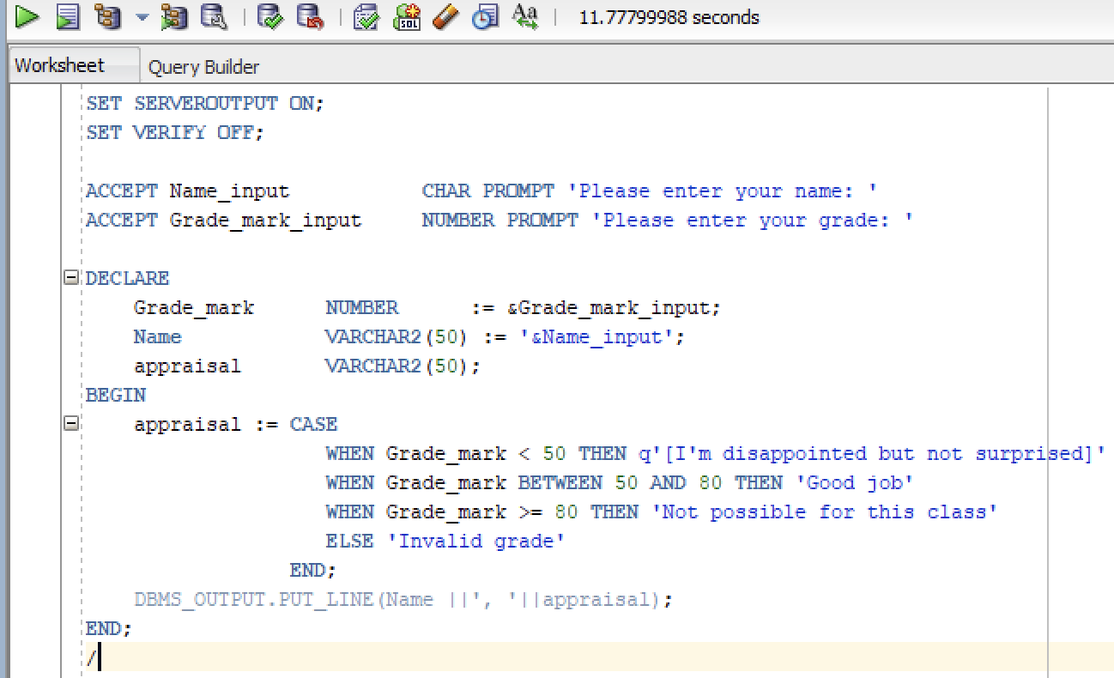
 | Output
 | 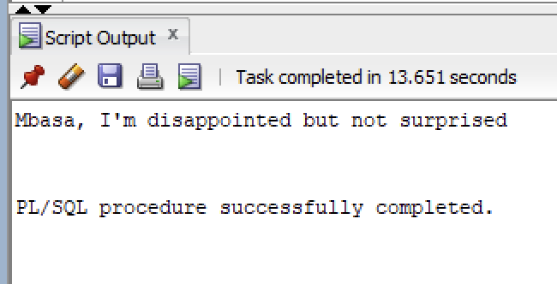
2 | PL/SQL code
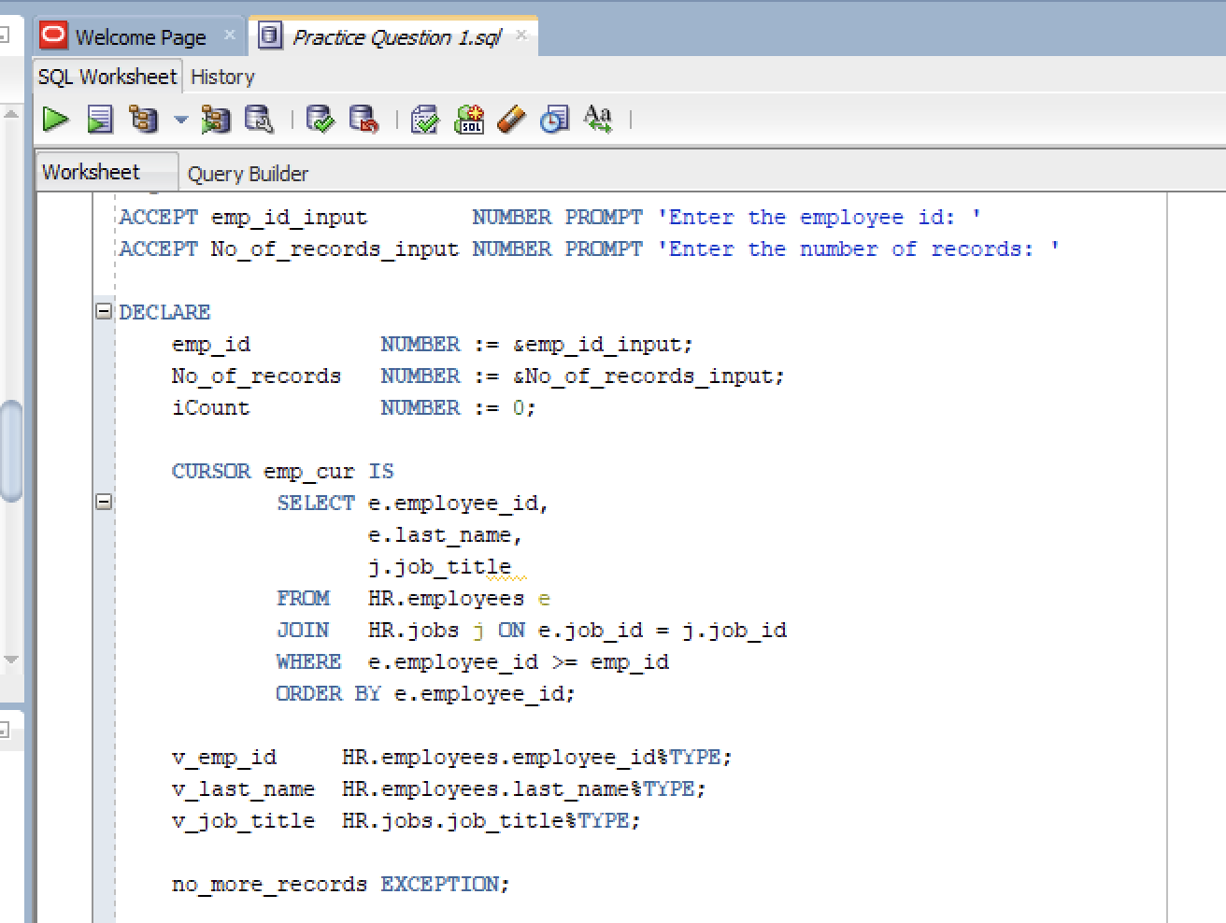
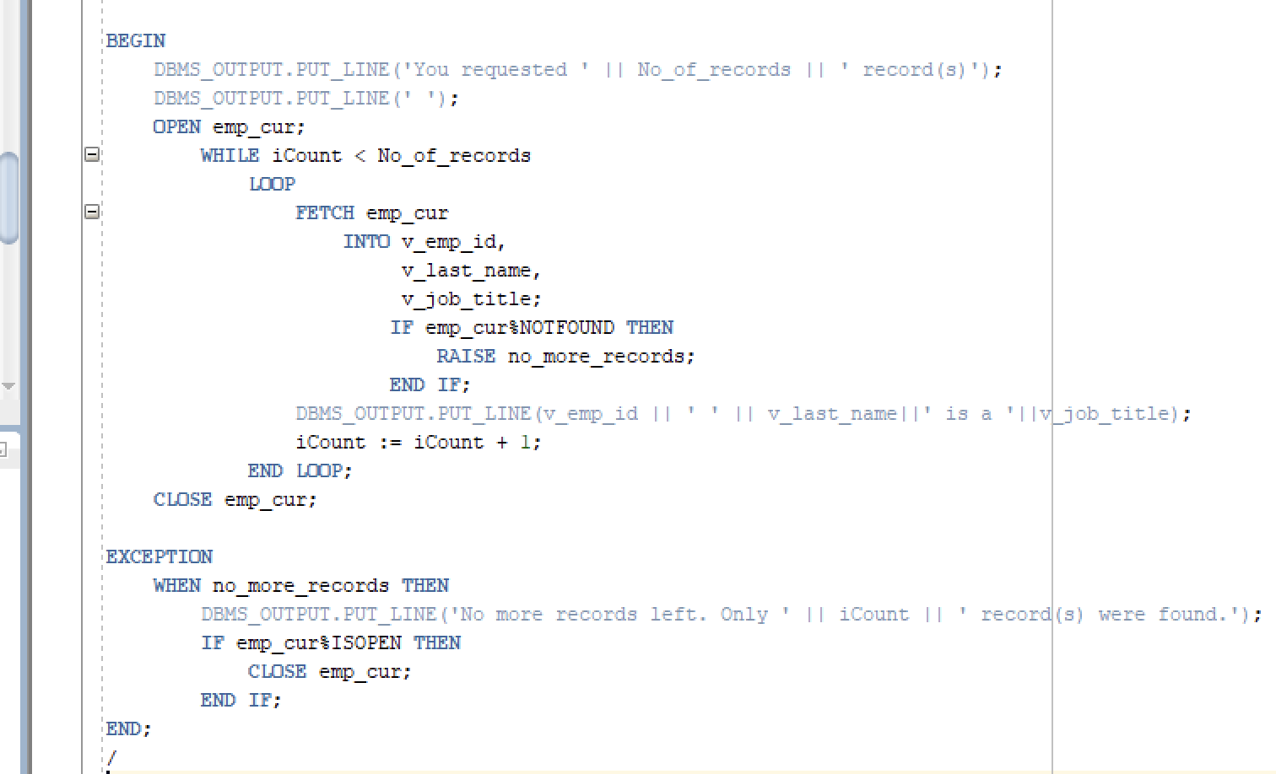
 | Output
 | 